American University of Beirut
Department of Electrical and Computer Engineering
EECE 350 – Computer Networks

HOMEWORK 3 SOLUTION

Problem 1. [17 points]

- Compute the overhead of error-correction, in number of additional bits, when sending a file of size 20 million Bytes, using 8,000-bit frames. You need to determine first the number of bits (r) you need for error correction, using Hamming’s formula. Assume that the header of a frame includes the error correction bits only. This means that 8,000+r bits are sent for each frame. [7 points]

File Size = $20 million Bytes=160 million bits$

Each frame will carry up to 8000 bits. We need 20,000 frames to carry the whole file.

Since Hamming’s Code will be used as forward error correction, the number of bits r should satisfy the following:
$\left(n+r+1\right)≤2^{r}$

For n = 8000 & r = 13:

$$\left(8000+13+1\right)≤8192$$
$$8014≤8192$$

Hence, the overhead is: $20,000×r=260,000 bits$

- If single-bit errors (per frame) occur during the transmission of the 20-million Byte file, the error will be automatically corrected using the error-correction scheme. An alternative is to use error detection, by sending a single parity bit with every 8,000 bits of data. When the error is detected, the corresponding frame is re-transmitted (assume that the overhead of feedback, when the receiver informs the sender that the frame is in error, is 400 bits). At what BER does the overhead of error detection (in additional number of bits, on top of file size) become equal to that of error correction? [10 points]

Frame error rate: p
Expected number of frame transmissions: 1/(1–p)
Number of frame retransmissions: 1/(1–p) –1 = p/(1–p)
Overhead =
parity bit (one bit per frame) + feedback when there is error + frame retransmissions =
1/(1–p) + 400 p/(1–p) + 8000p/(1–p)
(1+8400p)/(1–p)
Error correction overhead = 13 bits => (1+8400p)/(1–p) = 13 => p = 12/8413
Since p is small: p = 8001 x BER => BER = 1.783x10⁻⁷

Problem 2. [21 points]

T = 1010101111001010 is a CRC-coded message using generator G(x) = x⁴ + x + 1
- Find the original message D. Express D in hexadecimal. [7 points]

r = 4 bit CRC

D = 101010111100 = 0xABC

- Given that the received message is T* = 1011101110111100, what bits are in error?
[7 points]

Error Message = T xor T* = 0001000001110110

The bit numbers that are in error are: 1,2,4,5,6,12

- Is the error detected or not, and why? [7 points]

1011101110111100
10011
-------
0010001
10011
----------
00010110
10011
---------------
0010111
10011
------------------
0010011
10011
---------------------
0000000

No, because the division result obtained indicates that no error occurred, contrary to reality.

Problem 3. [32 points]

Consider a full-duplex 2 Mbps satellite link with a 250 msec propagation delay from sender (via satellite) to receiver. The data frames carry a useful data payload of size 10,000 bits. Assume that both ACK and data frames have 400 bits of header information, and that ACK frames carry no data.

Data Size = 10,000 bits

Frame Size = 10,400 bits

$$t_{cycle}=RTT+ t_{ACK}+t_{frame}$$

$$RTT=2×250ms=500ms$$

$$t_{ACK}=\frac{400 bits}{2 Mbps}=0.2 ms$$

$$t_{Frame}=\frac{10400 bits}{2 Mbps}=5.2 ms$$

$$t_{cycle}=505.4 ms$$

What is the effective useful data throughput:
- When using Stop-and-Wait? [8 points]

$$Throughput=\frac{Data Bits}{Cycle Time}=\frac{10000 bits}{505.4 ms}=19.786 kbps$$

- When using sliding windows with a sender window size W
  - What is the maximum possible effective useful data throughput? [8 points]

Maximum when U=1

$$Useful Data Throughput=\frac{Data Bits}{Frame Time}×U=\frac{10000 bits}{5.2 ms} =1.923076 Mbps$$

  - What minimum value of W will give this maximum? [8 points]

$$U=\frac{W×t_{Frame}}{t_{cycle}}=1$$
$$W=\frac{t_{Cycle}}{t_{Frame}}=97.2 →W=98 ;W must be an integer$$

  - How many bits are needed in the frame header for such a window size for Go-Back-N? For Selective Repeat? [8 points]

For Go-Back-N:

$$W≤MaxSeq$$
$$98≤2^{7}=128 →7 bits are needed$$

For Selective Repeat

$$W≤\frac{MaxSeq+1}{2}$$
$$98≤\frac{2^{8}+1}{2}=128.5 →8 bits are needed$$

Problem 4. [30 points]

Two 3G users A and B are communicating using the system shown in the figure below. The frames have 4000 bits, ACKs are negligible in size, and the processing time at intermediate switches is 10 microseconds (at each switch, and in the two directions). Assume that frame transmission is error-free and that the signal propagation speed in the fiber is 0.7c.

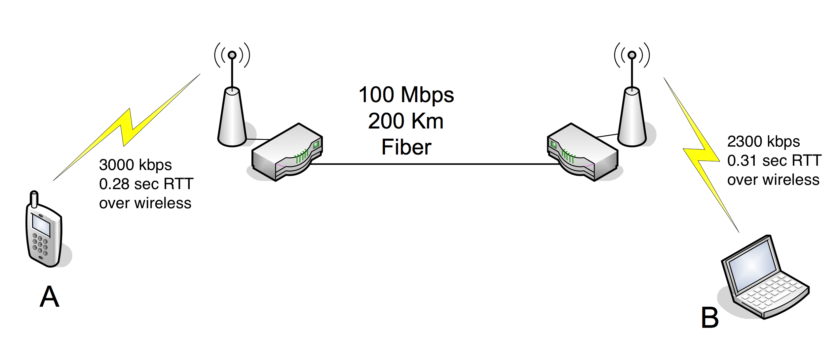

- Find the maximum throughput from A to B when each wireless link uses Stop-and-Wait. [15 points]

$$t_{A|Frame}=\frac{Frame Size}{{BitRate}_{A}}=\frac{4000 bits}{3000 kbps}=1.33 ms$$

$$U_{A}=\frac{t_{Frame}}{t_{cycle}}=\frac{t_{Frame}}{t_{Frame}+{RTT}_{A}+t_{Processing}}=\frac{1.33×{10}^{-3}}{1.33×{10}^{-3}+0.28+{10}^{-5} }=4.72 ms$$

$${Throughput}_{A}={BR}_{A}×U_{A}=3000kbps ×U_{A}=14.217 kbps$$

$$t_{B|Frame}=\frac{Frame Size}{{BitRate}_{B}}=\frac{4000 bits}{2300 kbps}=1.74 ms$$

$$U_{B}=\frac{t_{Frame}}{t_{cycle}}=\frac{t_{Frame}}{t_{Frame}+{RTT}_{B}+t_{Processing}}=\frac{1.74×{10}^{-3}}{1.74×{10}^{-3}+0.31+{10}^{-5} }=4.72 ms$$

$${Throughput}_{B}={BR}_{B}×U_{B}=2300kbps ×U_{B}=12.831 kbps$$

The two throughput values are different due to the different natures of the two wireless links. The sender rate is effectively 14.217 kbps, while the receiver rate is effectively 12.831 kbps. The difference in rates results in frames being buffered at the second router.

- Repeat the calculation assuming now that Stop-and-Wait is used end-to-end between A and B. [15 points]

Frame travels from A over the first wireless link, then over the fiber link and finally over the second wireless link to B.
B sends the ACK that take the same route to A but in the opposite direction.

$$t_{total}=t_{A|Frame}+\frac{1}{2}{RTT}_{A}+ t_{Processing}+t_{Fiber|Frame}+t_{Propagation| Fiber}+t_{Processing}+t_{B|Frame}+\frac{1}{2}{RTT}_{B}+\frac{1}{2}{RTT}_{B}+t_{Processing}+t_{Propagation| Fiber}+t_{Processing}+\frac{1}{2}{RTT}_{A}$$

$$t_{Propagation| Fiber}=\frac{200 km}{0.7C}=0.952 ms$$

$$t_{Fiber|Frame}=\frac{Frame Size}{{BitRate}_{Fiber}}=\frac{4000 bits}{100,000 kbps}=0.04 ms$$

$$t_{total}=0.5951 s$$

$$Throughput=\frac{Data Bits}{t_{total}}=\frac{4000 bits}{0.5951 s}=6.722 Kbps$$

